Raspberry Pi

What is Raspberry Pi?
The Raspberry Pi is a credit card sized computer that plugs into your TV and a keyboard. It is a little device that enables people of all ages to explore computing and to learn how to program in languages such as Python and Scratch. It was created with the intention of teaching people how to code and has since become one of the most popular devices for powering DIY projects and inventions. The Raspberry Pi has a wide range of applications, from helping you learn to code to building your own home media center.
It has a wide range of applications in various fields such as education, healthcare, manufacturing et cetera. It also has ability to do everything you'd expect a desktop computer to do, from browsing the internet and playing high-definition video, to making spreadsheets, word-processing, and playing games. 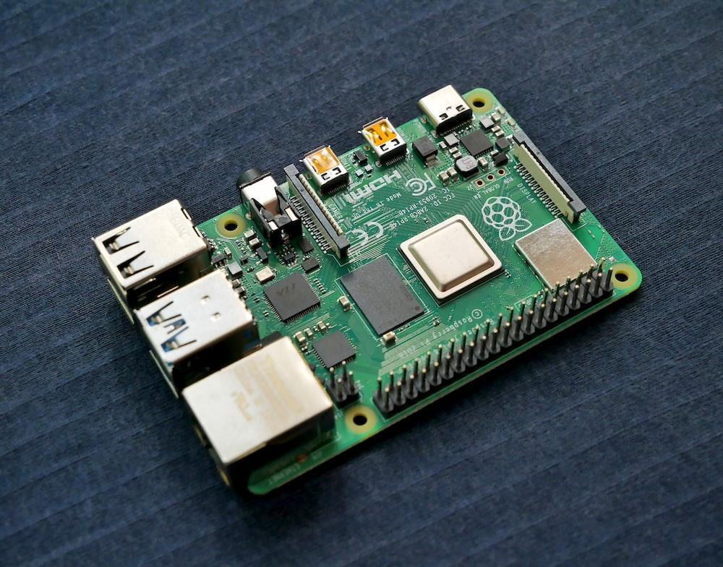

The history of Raspberry Pi
The Raspberry Pi was developed by the Raspberry Pi Foundation, a UK charity that aims to promote the teaching of basic computer science in schools. The Foundation was founded in 2009 by Eben Upton, Rob Mullins, Jack Lang, and Alan Mycroft, who were all concerned about the declining number of students studying computer science. They wanted to create a low-cost, easy-to-use computer that would encourage people to learn programming. The first Raspberry Pi was released in February 2012, and since then over 19 million units have been sold.
There have been several different models released, each offering different specs and features. The latest model is the Raspberry Pi 4, which was released in June 2019. The Raspberry Pi has been incredibly successful since its release in 2012. Over 14 million units have been sold and it has been used in a wide variety of applications. The low price and high performance of the Raspberry Pi make it a popular choice for education, hobbyists, and industrial applications. The Raspberry Pi has also been used in a variety of scientific research projects.
In 2012, the Raspberry Pi Foundation released the Model B. This more powerful model included a quad-core processor, 802.11n wireless LAN, and Bluetooth 4.0 support. The foundation also released a more powerful version of the original Model B, called the Model B+, in 2014.
In 2015, the foundation released the second generation of the Raspberry Pi, called the Model 2B. This version included a faster processor and more memory. The foundation also released a version of the Model 2B with a smaller form factor, called the Model A+.
In 2016, the foundation released the third generation of the Raspberry Pi, called the Model 3B. This version included a faster processor, more memory, and support for 4K video. The foundation also released a version of the Model 3B with a smaller form factor, called the Model 3A+.
In 2018, the foundation released the fourth generation of the Raspberry Pi, called the Model 3B+. This version includes a faster processor, more memory, and support for dual 4K video. The foundation also released a version of the Model 3B+ with a smaller form factor, called the Model 3A+.
These latest Raspberry Pi models, 3 A+ and 3 B+, released in November 2018 are the most powerful Pi models yet. The 3 B+ is particularly powerful, with a quad-core processor and built-in Wi-Fi and Bluetooth.
These latest models are just the latest in a long line of successful Pi models. The original Raspberry Pi was released in 2012 and was a huge success. Since then, there have been many different models released, each one more powerful than the last.
The Raspberry Pi has come a long way in a short time and is now an incredibly popular device. It's used by people all over the world for all sorts of different projects. Who knows what the future holds for the Pi?

The features of Raspberry Pi
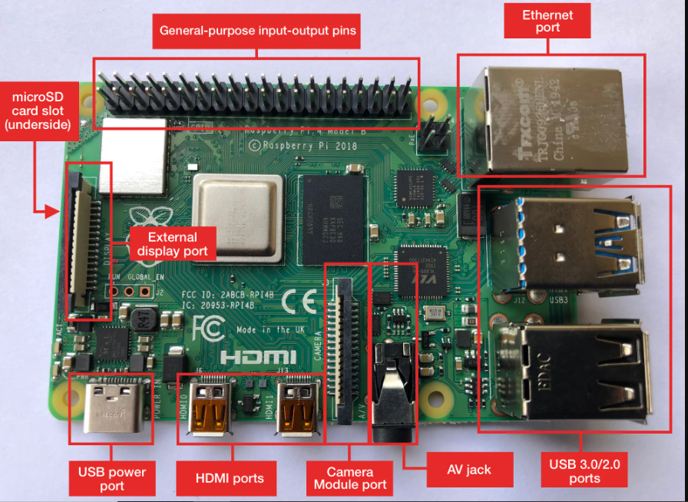

Raspberry Pi can be used for various purposes such as learning programming, building hardware projects, testing software and much more. It has many features that make it a great tool for learning and teaching. Some of the features of Raspberry Pi are listed below.
- Raspberry Pi has a Broadcom BCM2835 system on a chip (SoC) which includes an ARM1176JZF-S 700 MHz processor, VideoCore IV GPU, and 512 MB of RAM.
- It also has two USB ports, an HDMI port, an audio jack, and a microSD card slot.
- The Raspberry Pi is powered by a micro USB power supply and can be used with a variety of operating systems such as Raspbian, Ubuntu, and Windows 10 IoT Core.
Raspberry Pi is a great platform for learning programming. It has a wide range of programming languages that can be used on it such as Python, Scratch, and Java. It also has a number of GPIO pins that can be used to control external hardware.

Is Rasberry Pi important?
In conclusion, Raspberry Pi foundation’s goal is to get people coding and this little computer is one way of doing that. It’s cheap, it’s easy to use and it’s got a huge amount of support behind it. There is no doubt that the Raspberry Pi has taken the single-board computer world by storm. The little device has been used in all sorts of projects, from weather stations to media centers. It has even been used in industrial applications. With the release of the Raspberry Pi 4, the possibilities are endless. The Raspberry Pi is also a great way to get started with building your own projects.

